**Simplilearn-_Phase_-2_-project-_FSJD-_ Learner’s Academy**

**Project Detail**

Project Name: Learner’s Academy

**Project Version: 1.0**

**GitHub repository link:**

[**https://github.com/ankitsinghpawar2022/Simplilearn-_Phase_-2_-project-_FSJD-_-Learner-s-Academy**](https://github.com/ankitsinghpawar2022/Simplilearn-_Phase_-2_-project-_FSJD-_-Learner-s-Academy)

**Project Details:** This project is for the design and developing a backend administrative portal for the Learner’s Academy using Java EE technologies

**Objective**: The Objective of this project is to apply servlet, jsp and JDBC hibernate concepts.

**Developer Detail**

Name: Ankit Singh Pawar

Simplilearn user ID: [ankitsinghpawar@gmail.com](mailto:ankitsinghpawar@gmail.com)

**Technologies and tools Used:**

* Servlet: to do the business logic and works a controller for the project.
* JSP: to handle the presentation view.
* SQL: to create and manage the database.
* JDBC/Hibernate : to make operations on the database for the project.
* CSS: to format the contents.
* Eclipse: to write and run the code.
* Tomcat: to run and deploy servlet application.

**Flow Chart:**

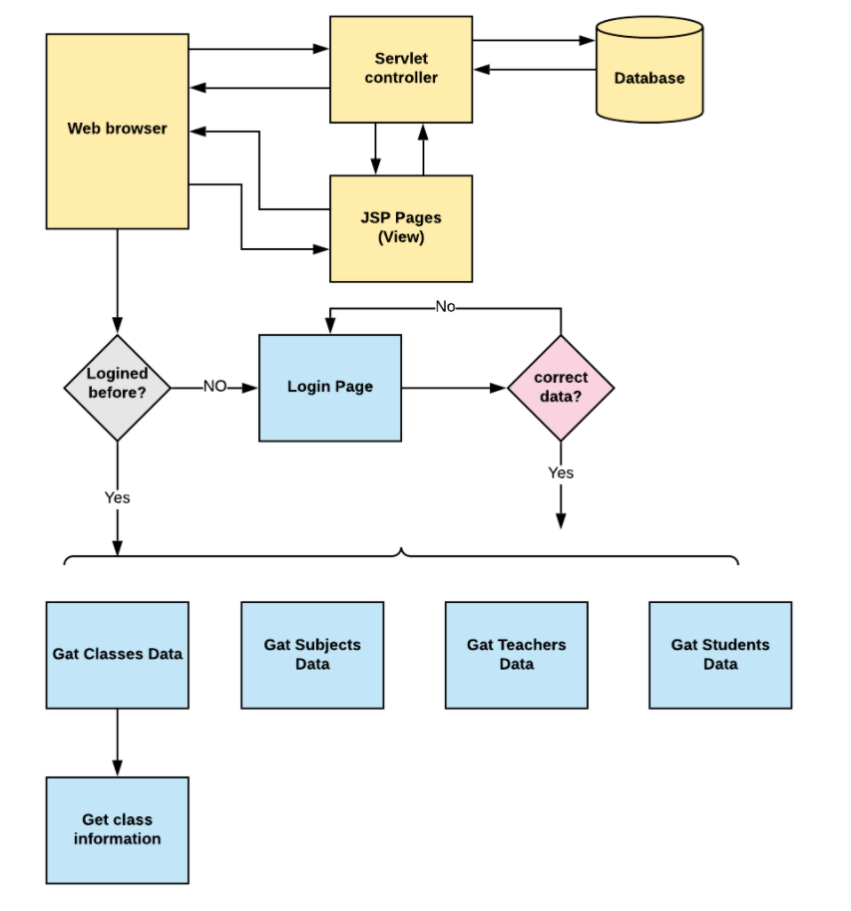

**Sprint Plan:**

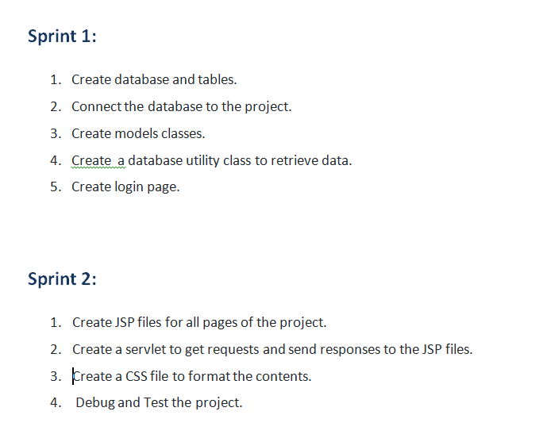

**Concept used in this programme:**

1. Object-Oriented: used to create and model objects for users and their credentials.
2. Databases: used to store and retrieve data.
3. Data Sources: used to define a set of properties required to identify and access the database.
4. Collections: used some collections such arraylist to store collection of data.
5. Exception Handling: used to catch problems that arises in the code especially in I/O blocks.
6. Cookies: to store log-in data on the client browser. Searching and Sorting

**How to run the program:**

1. clone project
2. Import\create mysql database “learners_academy” file to your database administration tool.
3. Go to “\src\main\webapp\index.jsp.
4. Edit the database’ properties such as username, password and driverClassName to be suit to your database administration tool.
5. Now run program on a server.
6. To login you must enter admin for both username and password.